The Kendra Kimbrough Dance Ensemble

The Kendra Kimbrough Dance Ensemble (KKDE) was founded in 1996 by Kendra Kimbrough Barnes. The Ensemble’s mission is to bridge diverse cultures and communities through thought-provoking performances that address common human experiences. KKDE represents a range of ages and body-types and incorporates a variety of dance styles to inform audiences about a variety of sociocultural issues. The Ensemble creates and presents dance works that build upon a wide array of dance genres, including a fusion of modern dance with movement from African, Brazilian, and North Indian cultures.

Since its founding, KKDE has self-produced numerous home seasons in Oakland, as well as producing concerts and collaborations in San Francisco. Artistic Director Barnes has worked in collaboration with dancers, musicians, and poets. KKDE has toured throughout Southern and Northern California and in Salvador, Bahia Brazil, and performed in several Bay Area dance festivals, including the East Bay Dance Series, Oakland Arts Festival, WestWave Dance Festival, Black Choreographers Festival, and ODC’s Pilot and House Special. Barnes is also an alum of the Artist in Residency program at Headlands Center for the Arts and at CounterPULSE/SF. With these critical resources and the mentorship of Rhodessa Jones of Cultural Odyssey, Barnes developed Home Is That Way?!, a dance-drama exploring the effects of the incarceration of a loved one on a family. KKDE creates socially conscious works most recently including ReDzONE, a dance ritual aimed at transmuting the trauma of sexual assault, as well as “Resilience In-Joy” a dance film which seeks to raise the collective vibration through the pursuit of joy in all its forms - both in creative collaboration with Jennifer Johns.

Directors

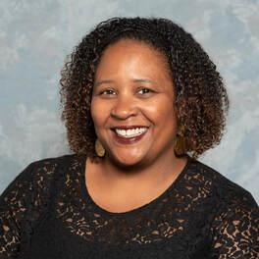
KENDRA BARNES, DIRECTOR ​​has studied Contemporary, African, Brazilian, Indian, Dunham & Horton Techniques. She has performed with the late Malonga Casquelourd’s Fua Dia Congo, Chitresh Das’ Chhandam School of Kathak Dance, and Carlos Aceituno as well as projects with Donald Byrd, Robert Moses, Bebe Miller, Bill T. Jones, and Rosangela Silvestre.

In 1996 she founded the Kendra Kimbrough Dance Ensemble (KKDE). Most recent works include notable dance-dramas: ReDzONE, In The Meantime, and Angst in collaboration with Delina Patrice Brooks. Currently Ms. Barnes is collaborating with Oakland veteran vocalist Jennifer Johns on Resilience In-Joy, cultivating and choosing joy in the midst of struggle.

She has been a guest choreographer for San Francisco State University Dance Department, Dimensions Extensions Youth Performance Ensemble, Move Dance Theater of Oakland, and Abundant Life Christian Fellowship (staging a 100+ cast for a 4,000+ audience). KKDE has presented work at the East Bay Dance Festival, Alice Arts Center, the Black Choreographers Festival, Summerfest/WestWave Dance Festival, ODC Pilot, PUSHfest and Dance Mosaic.

Barnes has taught dance to adults and children of all ages through Dimension’s Rites of Passage program in Oakland at the Malonga Casquelourd Center for the Arts and jazz, Pilates and yoga at San Mateo, Laney and SF City Colleges. She has been an artist in residence at the Headlands Center for the Arts and CounterPULSE.

Her work as co-choreographer (with Latanya d Tigner) for CalShakes’ Black Odyssey was a finalist for the Theater Bay Area Best Choreography Award and she was the 2018 recipient of a Broadway World award for Best Choreography as Choreographer for the African American Shakespeare Company’s (AASC) production of Ntozake Shange’s For Colored Girls Who Have Considered Suicide / When the Rainbow Is Enuf. Other work includes AASC's "Black Eagles" and Crowded Fire Theater's "INKED Baby"

Barnes is also co-founder/director for the Black Choreographers Festival (BCF), along with Laura Elaine Ellis (AAAPAC). Since 2005 BCF has served local, national and international artists with over 150 public events, acknowledging the diverse artistic expression within the context of African and African American dance and culture. Under her direction, K*Star*Productions, the presenting organization for BCF and KKDE, has received funding from the City of Oakland Cultural Arts Program, CA$H, The Irvine Foundation, the Zellerbach Family Fund, Alameda County Arts Commission, East Bay Community Foundation, California Arts Council, Alliance for California Traditional Arts, and The Walter and Elise Haas Fund Foundation.​

Barnes holds a BA in Dance from San Francisco State University and a MA in Arts Administration from Golden Gate University. She graduated with honors and is a recipient of the "Who's Who Among Students in American Universities and Colleges" Award and "Who's Who Among American Women.”

​A long time community and adjunct dance instructor she currently teaches dance at UC Berkeley and freelances as an administrator, teacher, and choreographer.

YENI LUCERO, ASSOCIATE ARTISTIC DIRECTOR was born in the small town of Chalchuapa. After coming to the Bay Area later in life, she began her training in West African dance at the age of 15 and soon pursued a more versatile training at San Francisco State University, where she obtained a BA in Dance and Choreography.

Dancers

OLIVIA ENG - REHEARSAL DIRECTOR, and INSTRUCTOR, has great passion for dancing, music, traveling, photography and poetry. She graduated from the University of California, Irvine, focusing on Dance Performance and Sociology. She loves and continually studies House, Modern, West African, Hip-Hop, Modern, Bhangara, Bollywood, Afro-Brazilian, and Salsa dance.

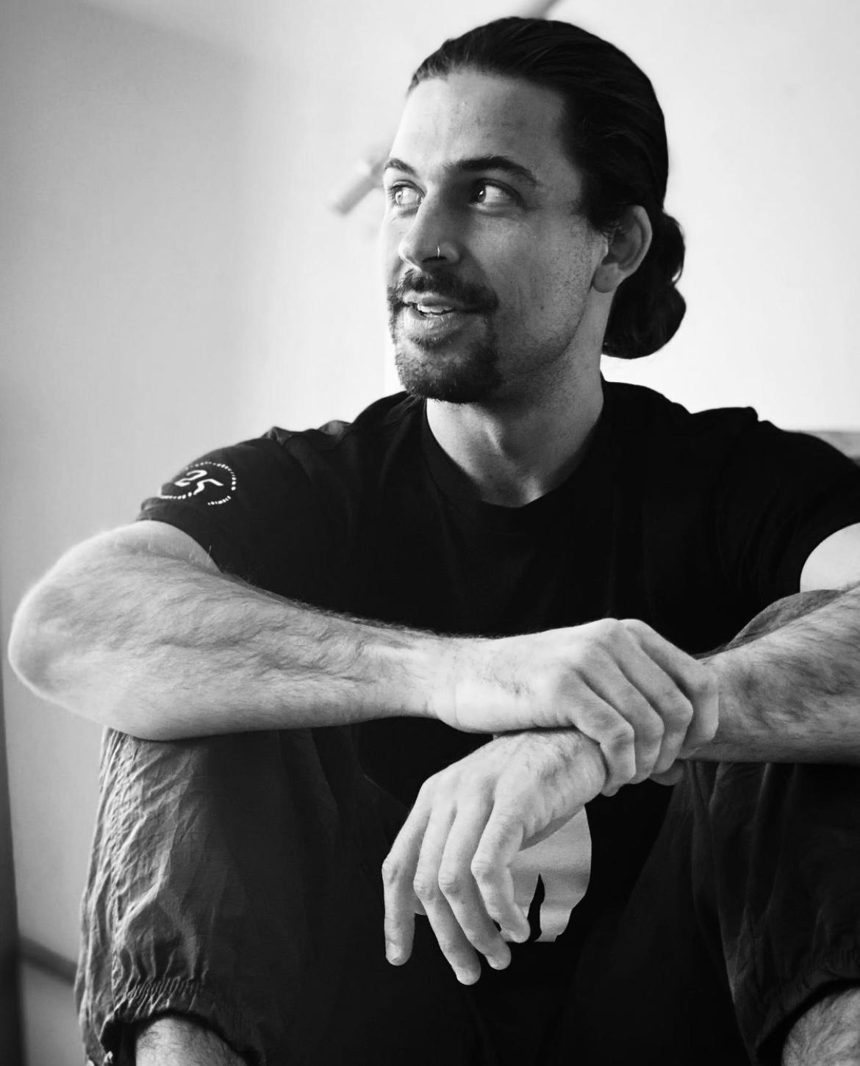
ZAK DYLAN - DANCER, "If you were to ask his grandmother, she would tell you that Zak, born and raised in San Francisco, came into this world dancing. After enough leaping and spinning around his family's Bayview home, at age 7 he began taking kid's dance classes with Micaya at Dance Mission. At age 9 he joined City Shock SF, a youth Hip-Hop Dance troupe, associated with Culture Shock Oakland, and led by Darnell Carrol. At age 15, Zak began training Capoeira under Mestra Marcia Cigarra in the Mission district, deeply attracted to the improvisational format and rhythmic flow of the martial art. His path within Capoeira led him to Brazil on four different trips, where he trained in Rio de Janeiro under various masters and competed in international competitions. At age 25, while in Brazil he was granted the high rank of Instrutor. In 2018, he began training House dance and other club/street styles at MVMNT Studio in Berkeley under members of the legendary breaking/house crew, Circle of Fire. Coming full circle back to dance, he has found the greatest joy in weaving his foundation of Capoeira into his other styles, onto the dancefloor of his favorite environment: the club. In joining the KKDE, Zak is inspired to deepen his spiritual journey in movement with the challenge of taking on new forms of dance and collaborating with fellow artists. Zak received his Associates degree in Arts & Humanities from City College of San Francisco in 2014; his Bachelor's in Society & Environment from University of California, Berkeley in 2016."

MIKA LEMOINE - APPRENTICE is from Oakland, California (Ohlone land), Mika Lemoine has over a decade of experience performing and teaching. She most recently held the title of Teaching Artist Mentor at Destiny Arts Center. In 2017, Mika co-founded See Through Soul, an Oakland-grown dance company that practices healing and storytelling through movement. She has a BA in Dance from UCLA’s department of World Arts and Cultures which informs her work at her company. Mika specializes in House dance, Hip Hop dance, and Waacking, and toured with Contra Tiempo Urban Latin Dance Theater (LA), Versastyle Dance Company (LA), and Embodiment Project (SF). Most recently, she danced in dana e. fitchett's evening length work neverfoundneverlost and currently performs with Mix’d Ingrdnt’s (Oakland).

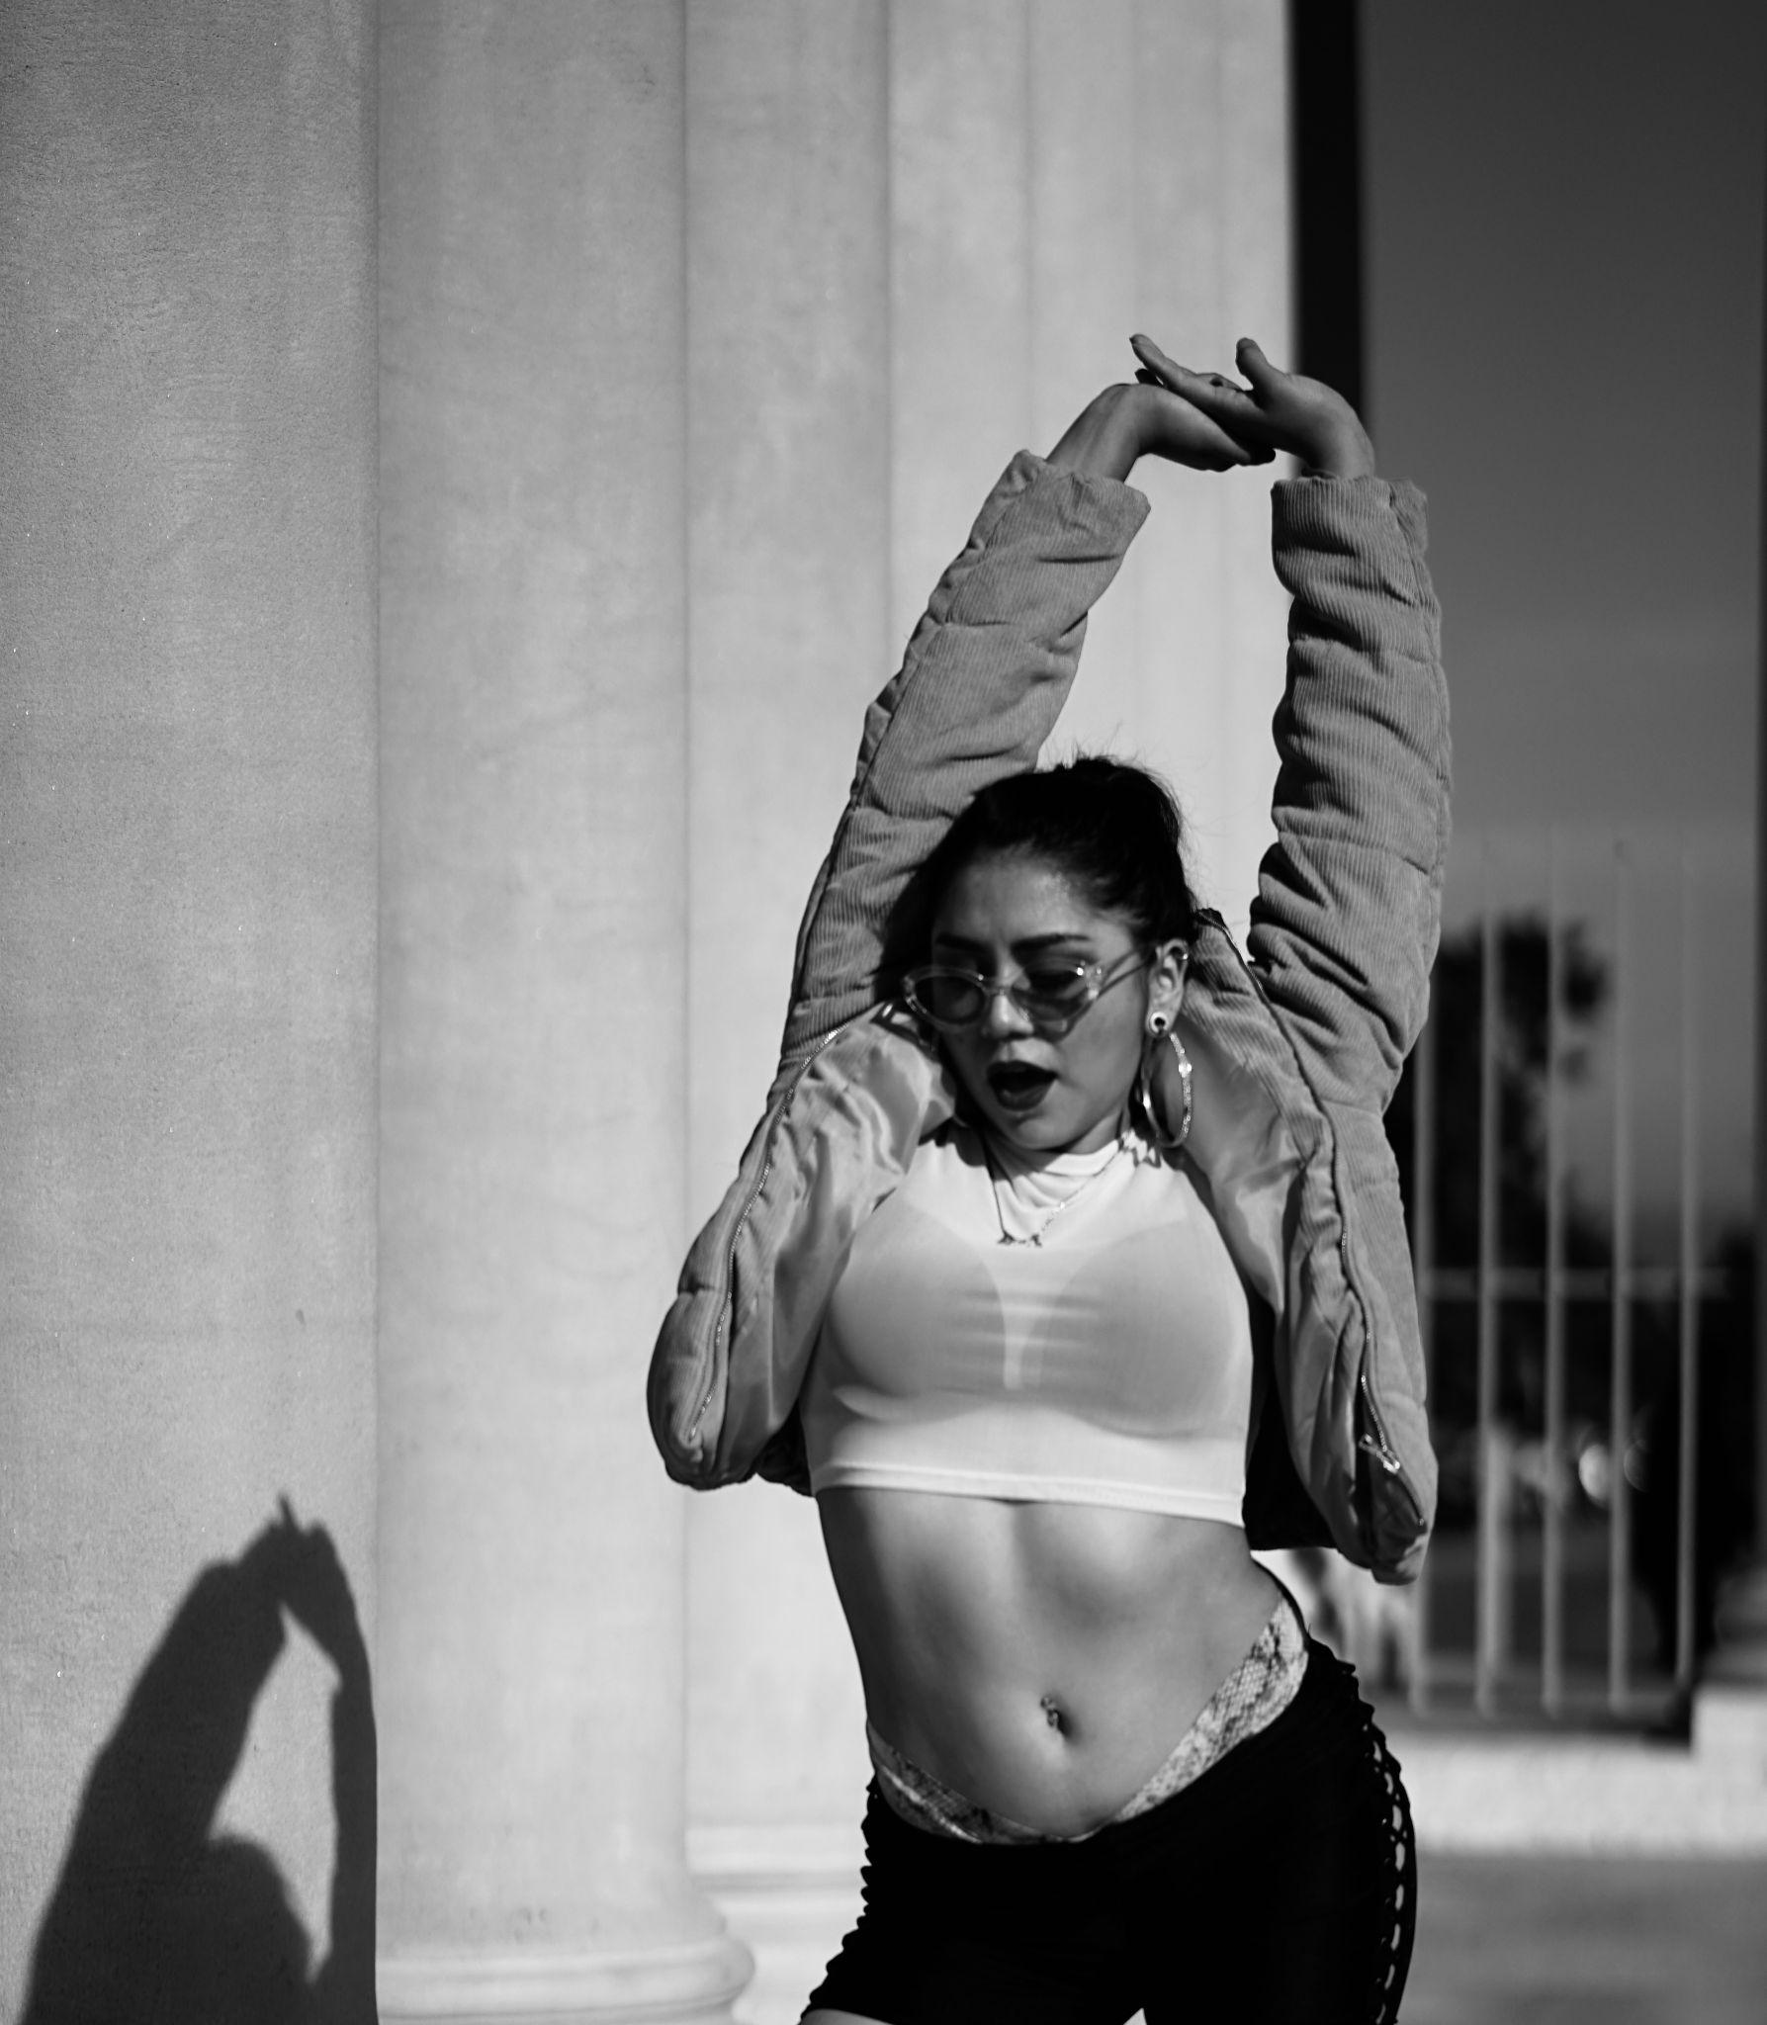
JOSELINE GRANADOS - APPRENTICE
Joseline "YO$HI" Granados (pronouns she/her) is an Oakland-based Creative Director, dancer, choreographer and dance instructor from Los Angeles, CA. She has trained in dance for over 15 years and has taught dance professionally for over 6 years. She moved to San Francisco in 2016 to pursue her dance career and in 2018, she graduated with a Bachelor's degree in Dance from San Francisco State University. After college, Joseline began to teach her Reggaeton workshops, using her impressive background in various dance styles such as: ballet, modern, jazz, hip-hop, heels, dancehall, afro dance, afro house and bachata.

Current Programming

Set to premiere Fall 2022 The Golden Thread is a multimedia dance-theater production that takes us on a journey through different worlds wherein time, timing and tempo are unique, subjective and relative to the people who live in that world. Each world provides a different key that allows us to unlock the door to momentum, that special vehicle on which ease and magical alignment take place.

Script & Direction: Delina Patrice Brooks
Choreography & Direction: Kendra Barnes
Choreography: Yeni Lucero

The Kendra Kimbrough Dance Ensemble also offers monthly and weekly classes both in person and virtually. Information for the next classes can be found at www.KKDE.net.
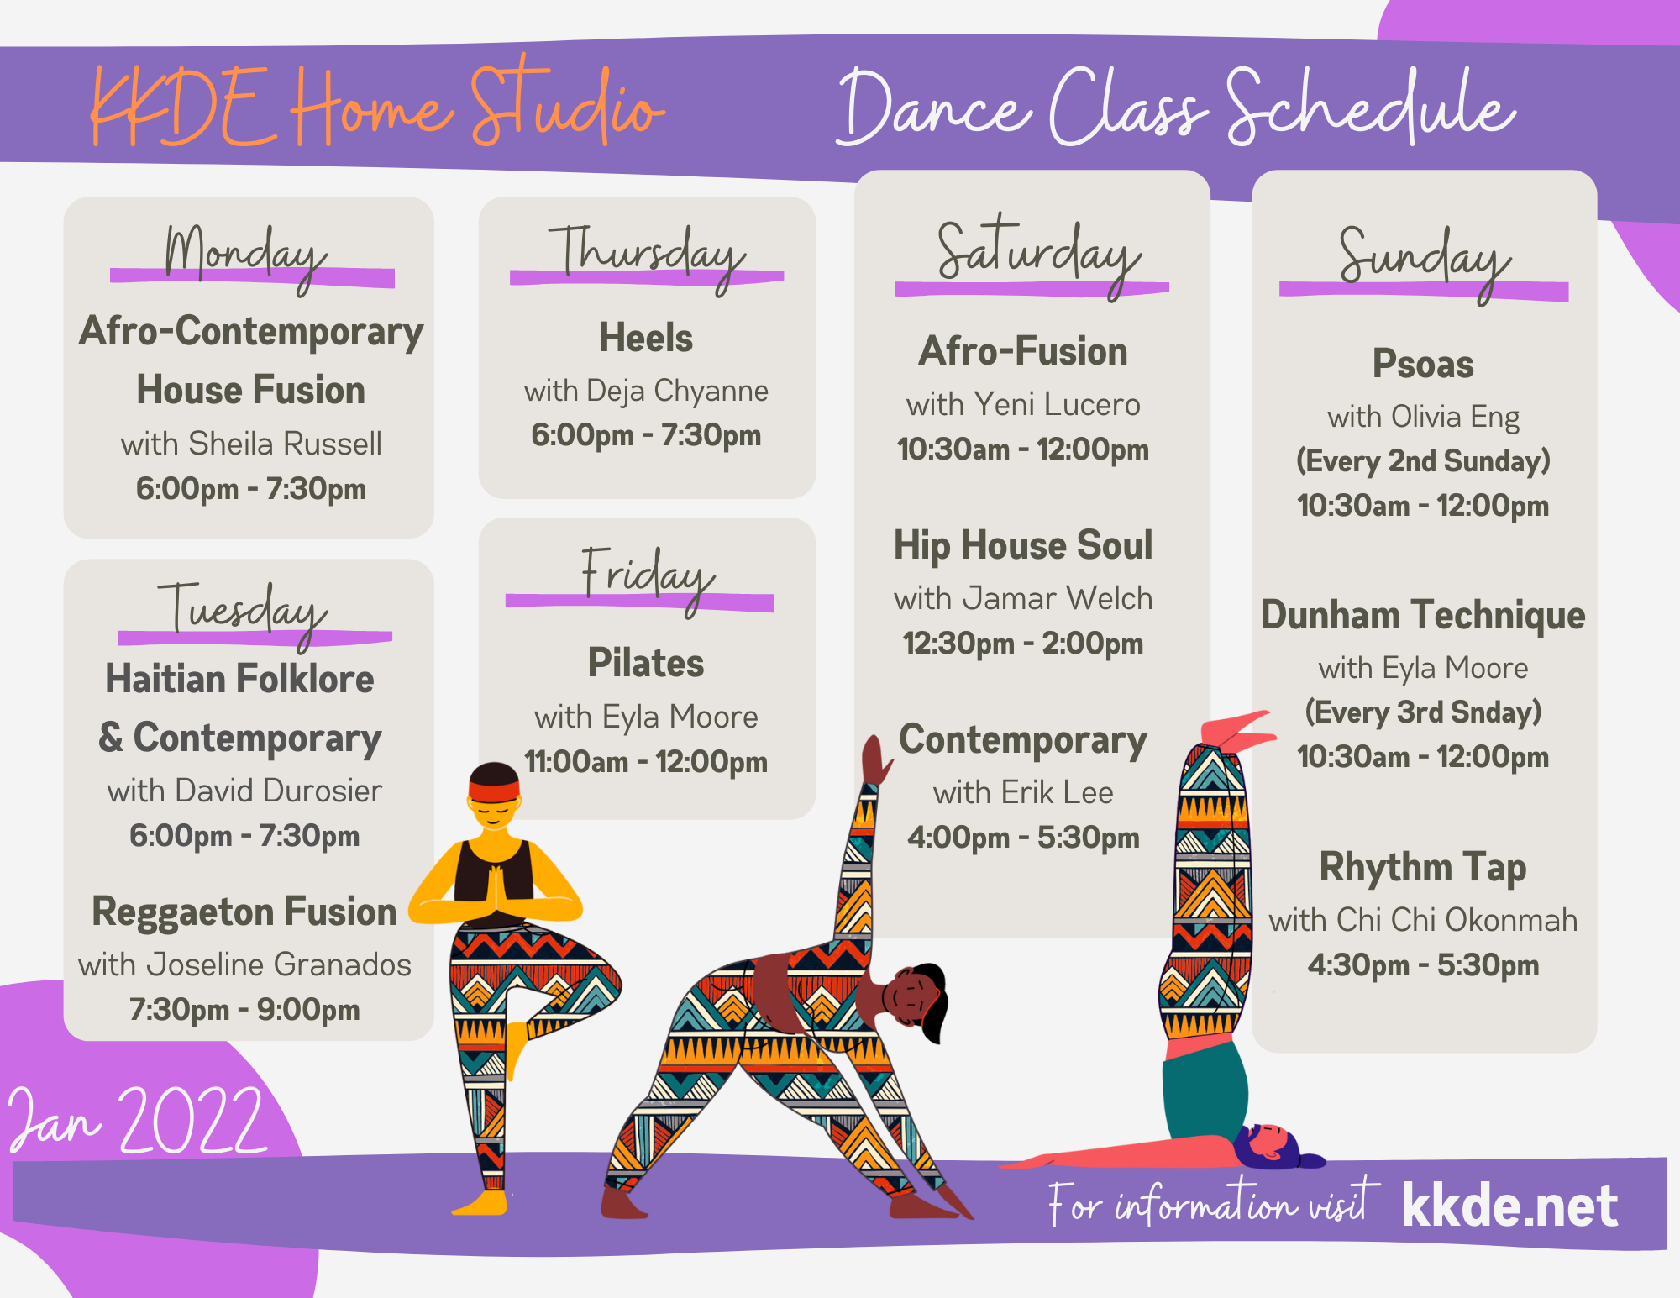

Featured Projects

“Resilience In-Joy”

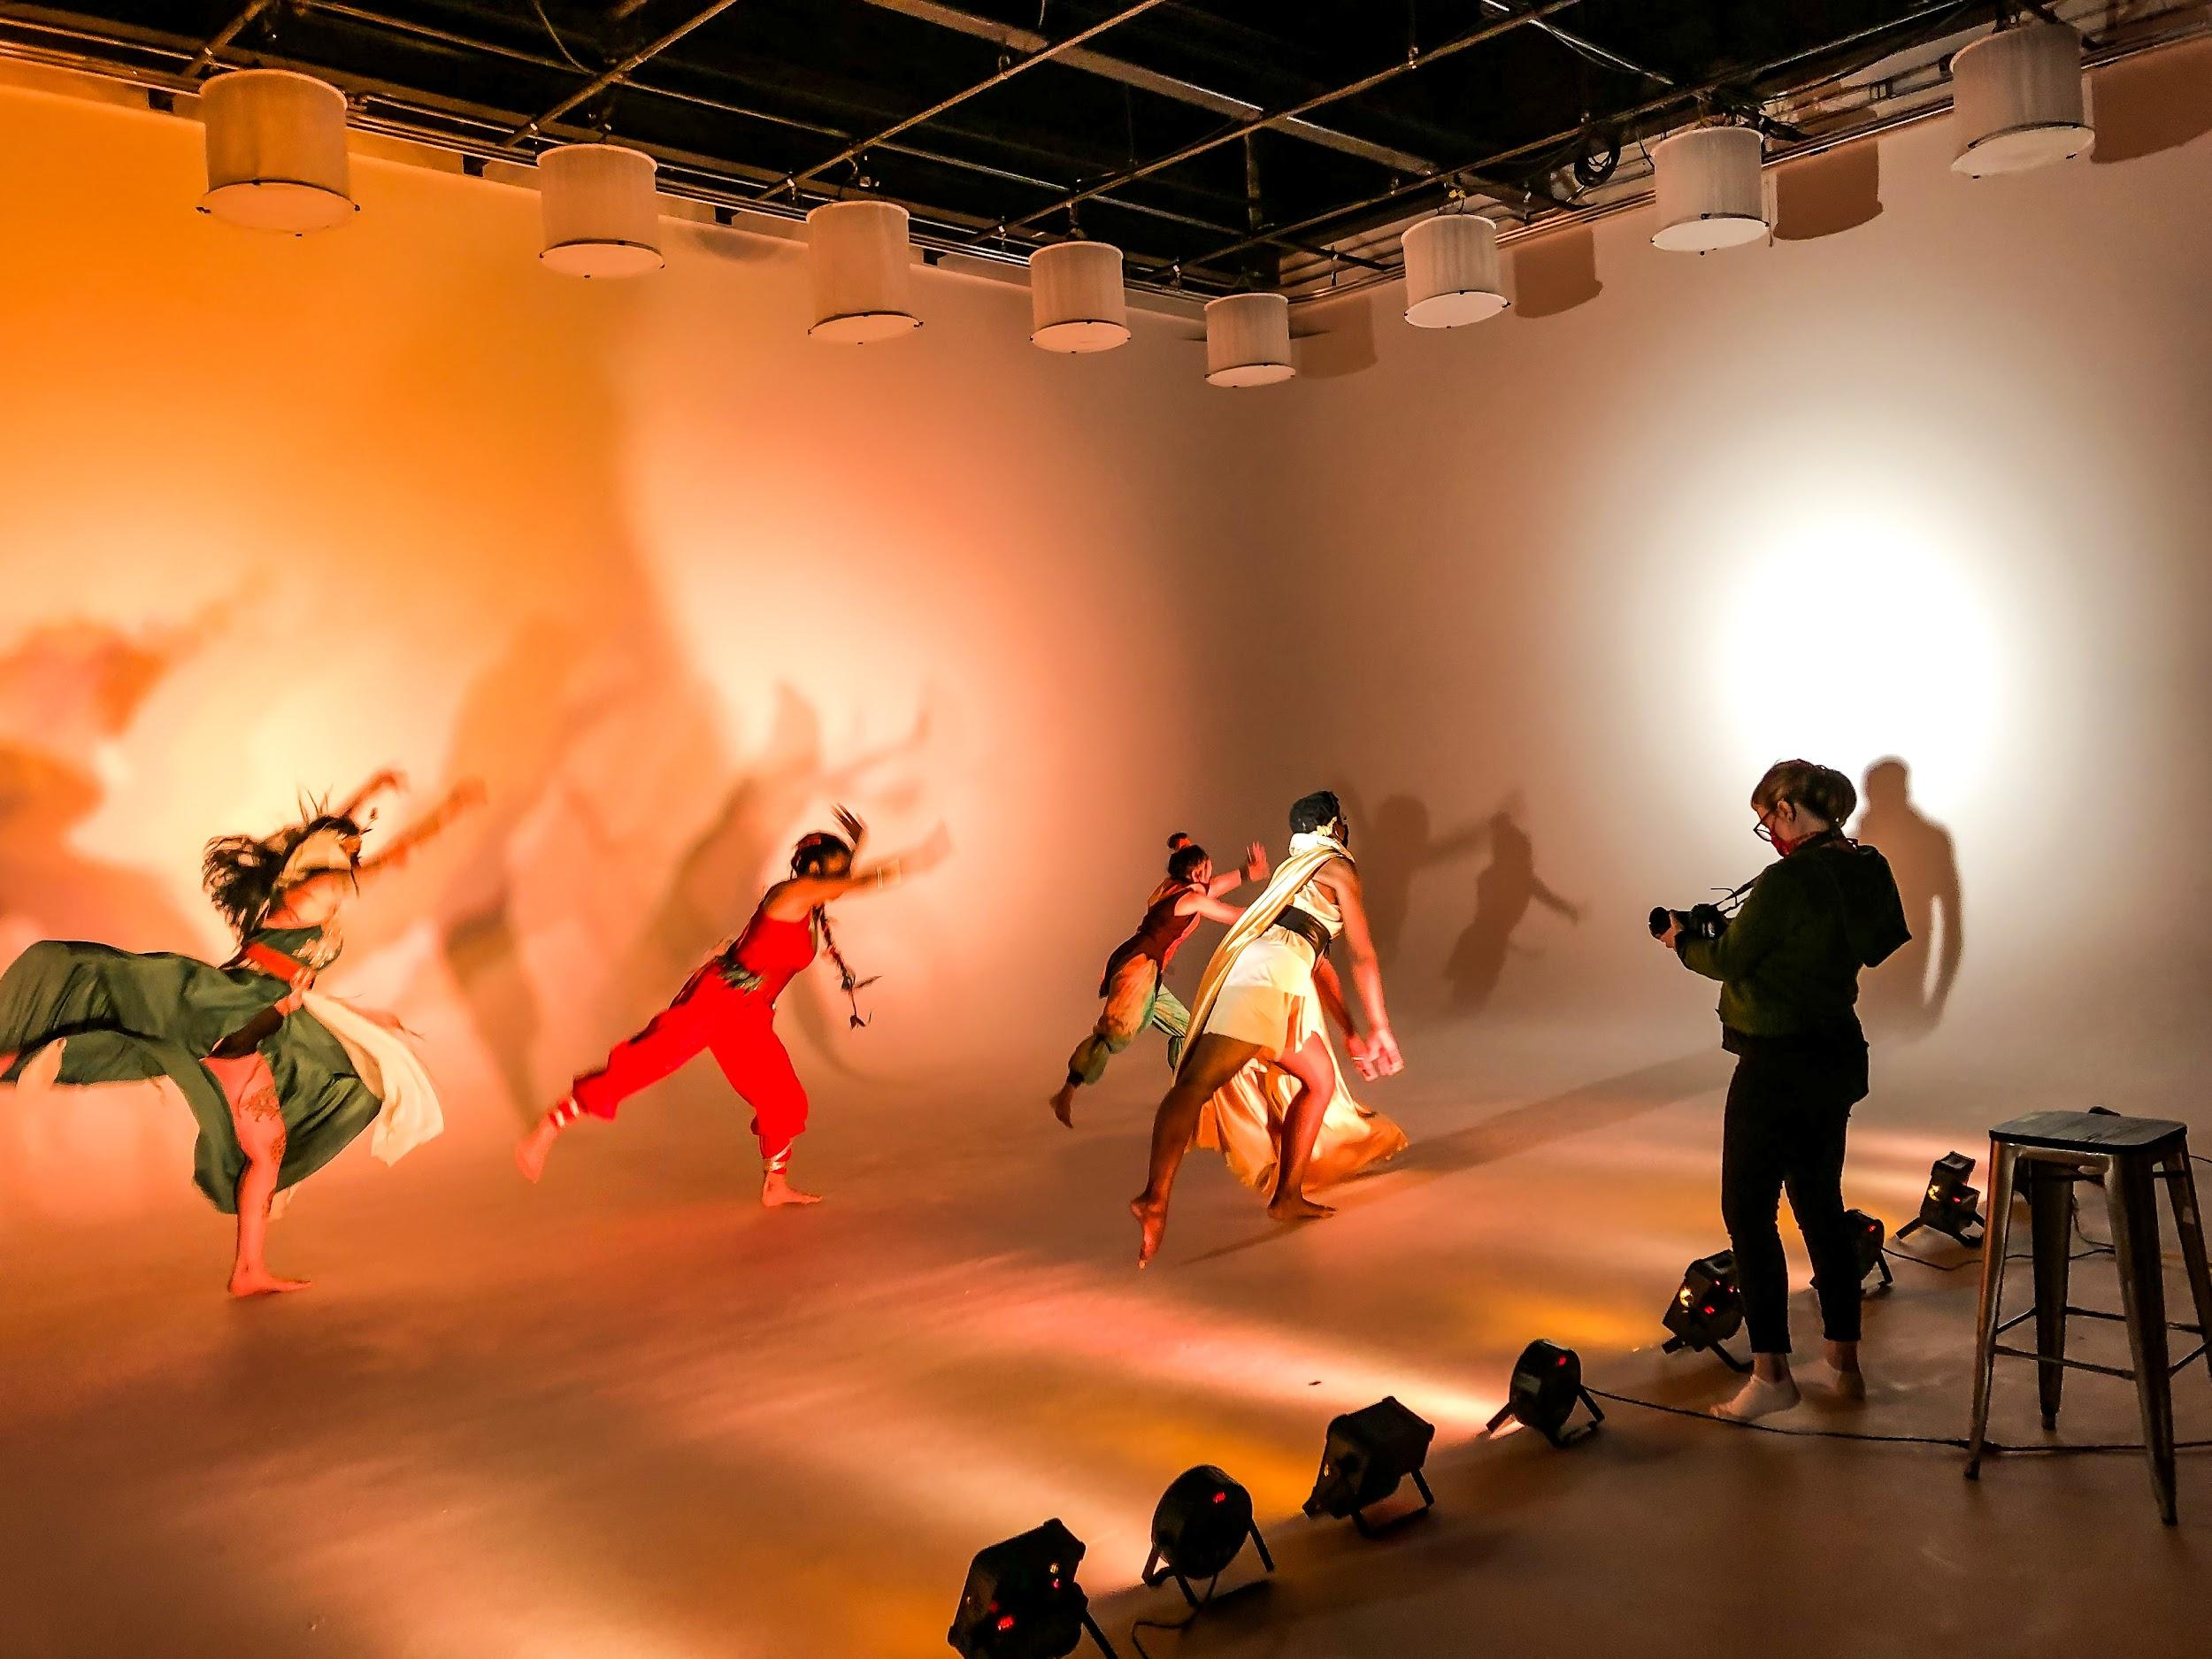

The Kendra Kimbrough Dance Ensemble is overwhelmingly proud and grateful to present our premiere dance film, “Resilience In-Joy”, created in collaboration with Jennifer Johns..
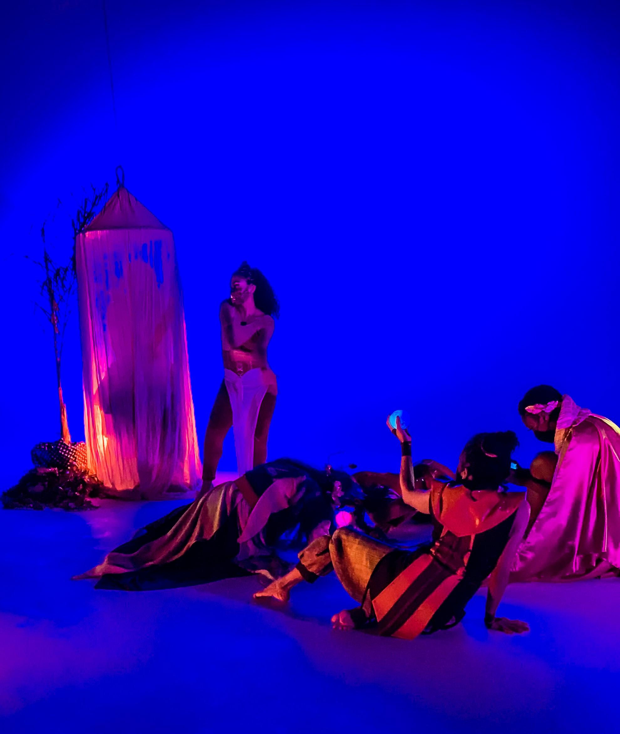

The intention of the "Resilience In-Joy" (working title) short dance film is to inspire participants to disarm and to recall that joy is a choice we can make in every moment regardless of our circumstances.

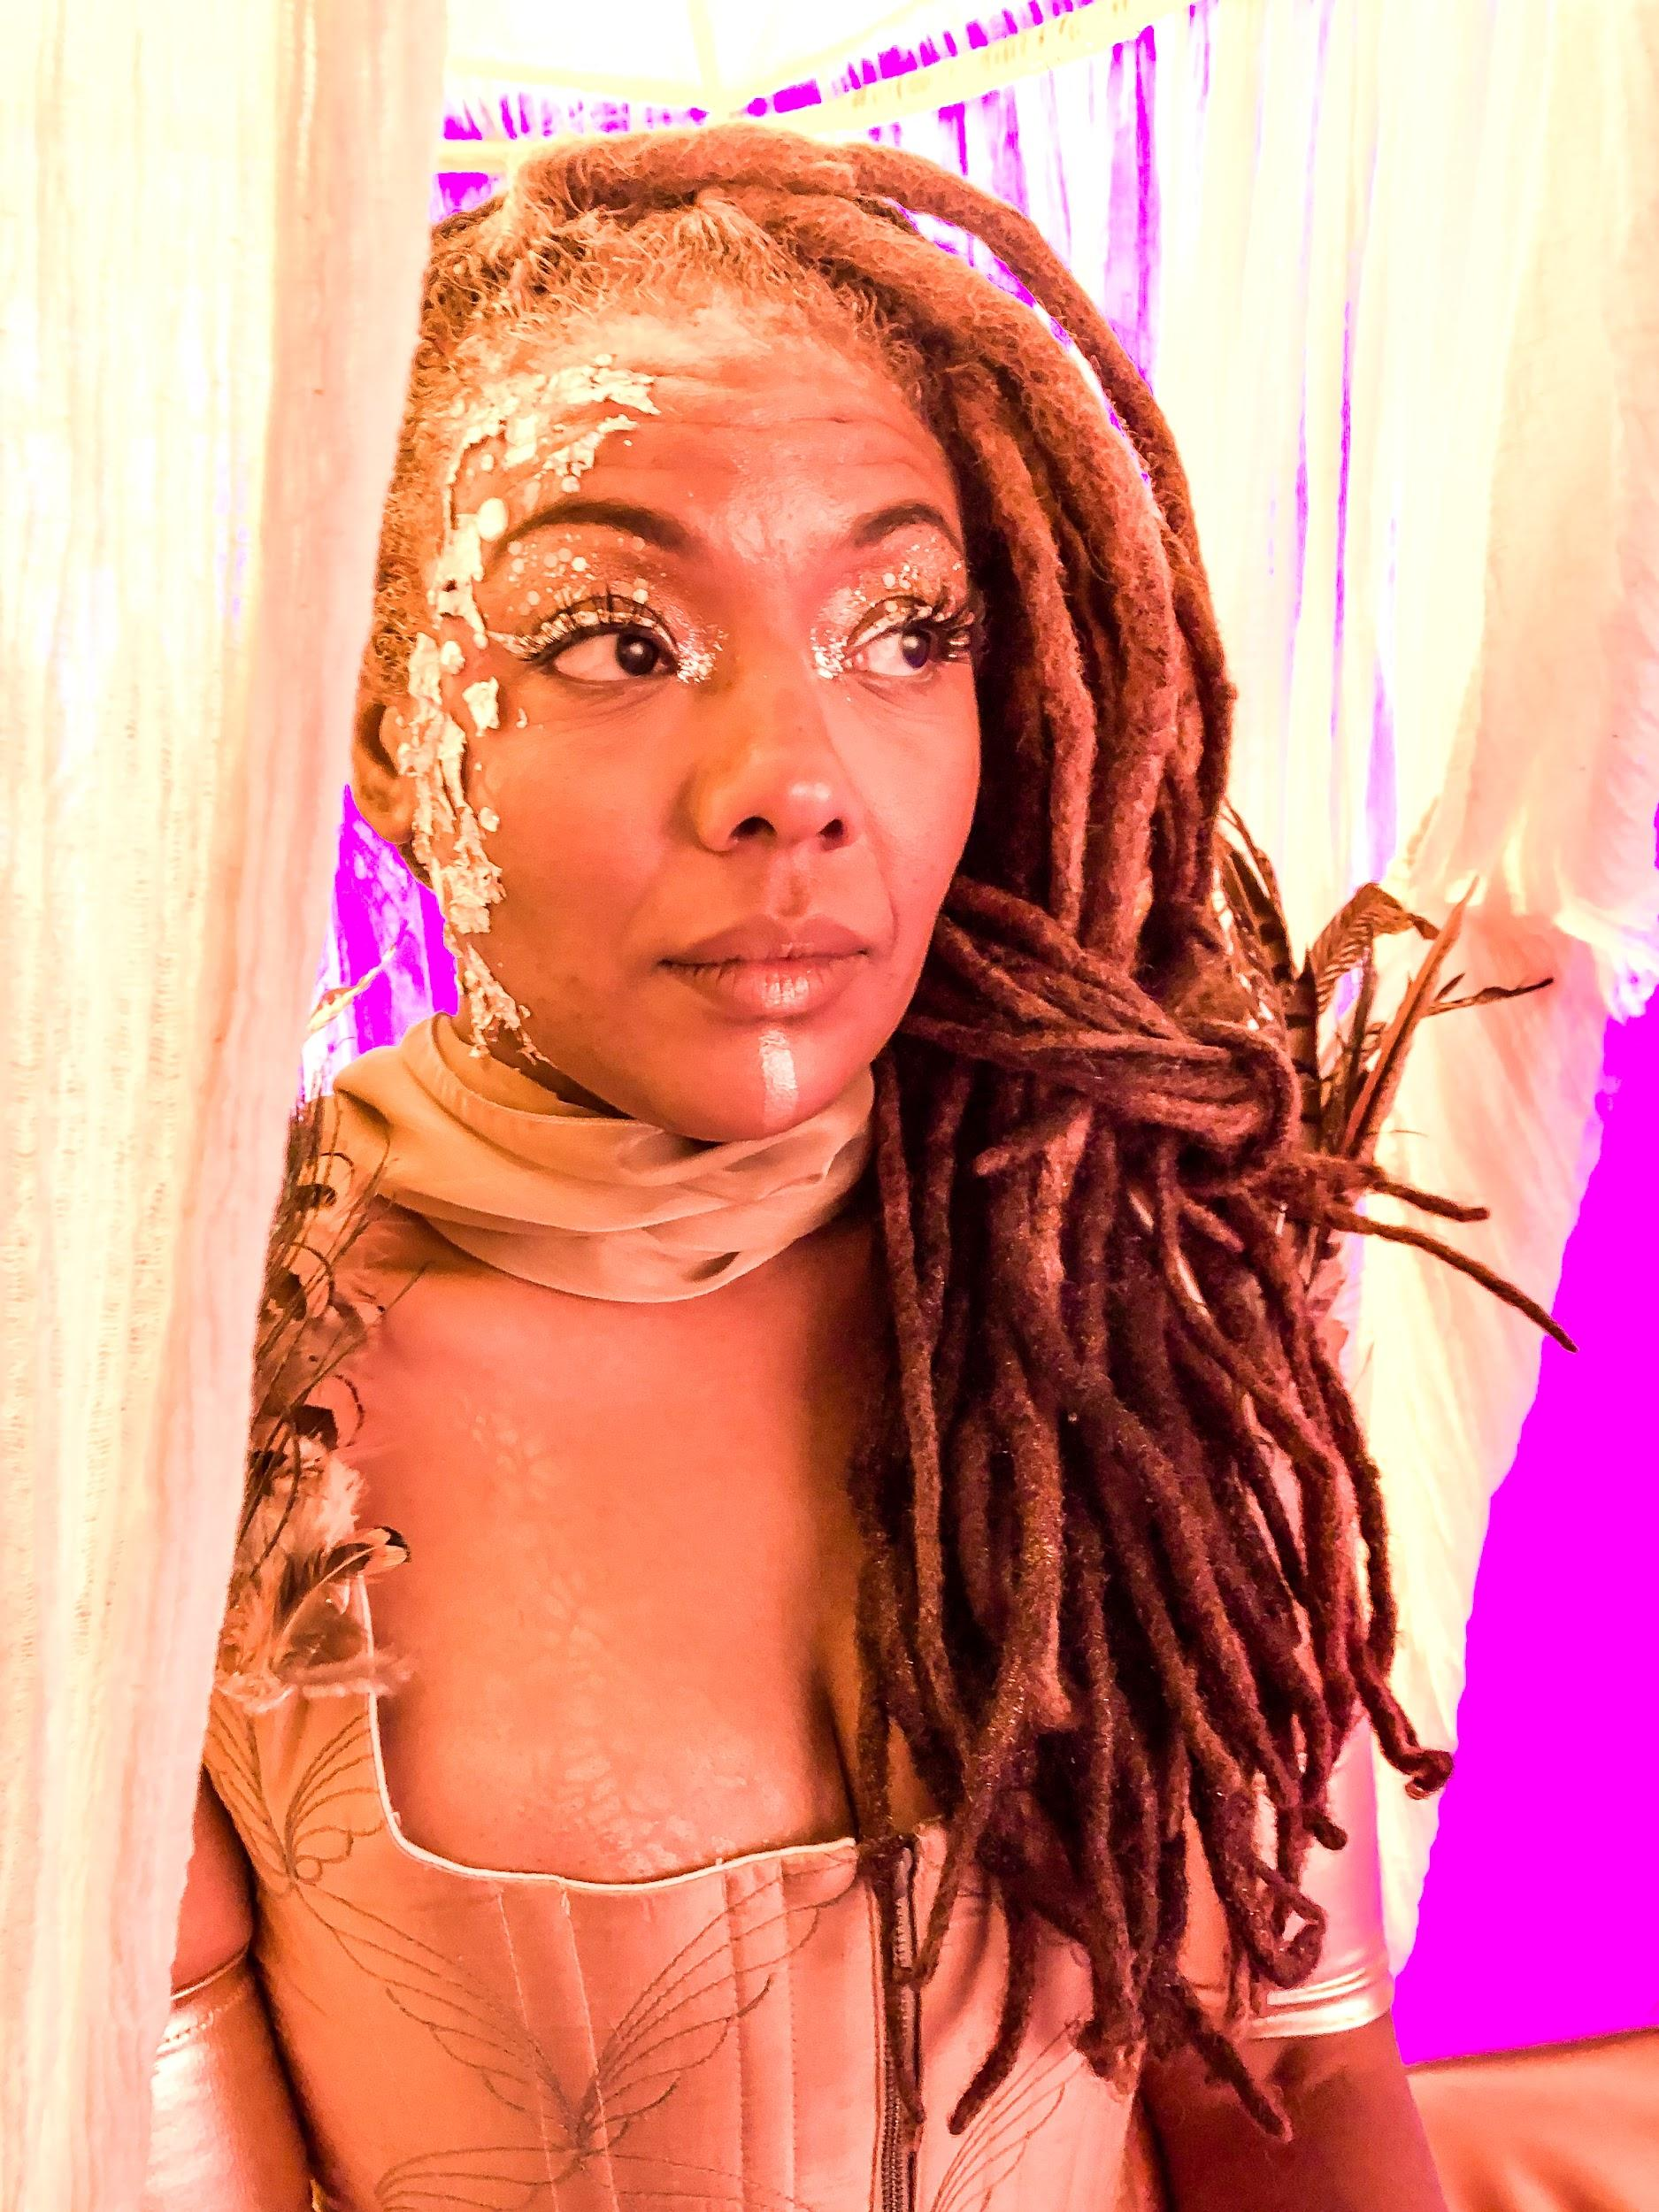

The film is a journey through music and dance, panoramic projection and fairies giving the participants the experience of being transported into another world.

