MEDIA CONTACT: Mary Carbonara, 415-845-9994 or marycarbonara@gmail.com

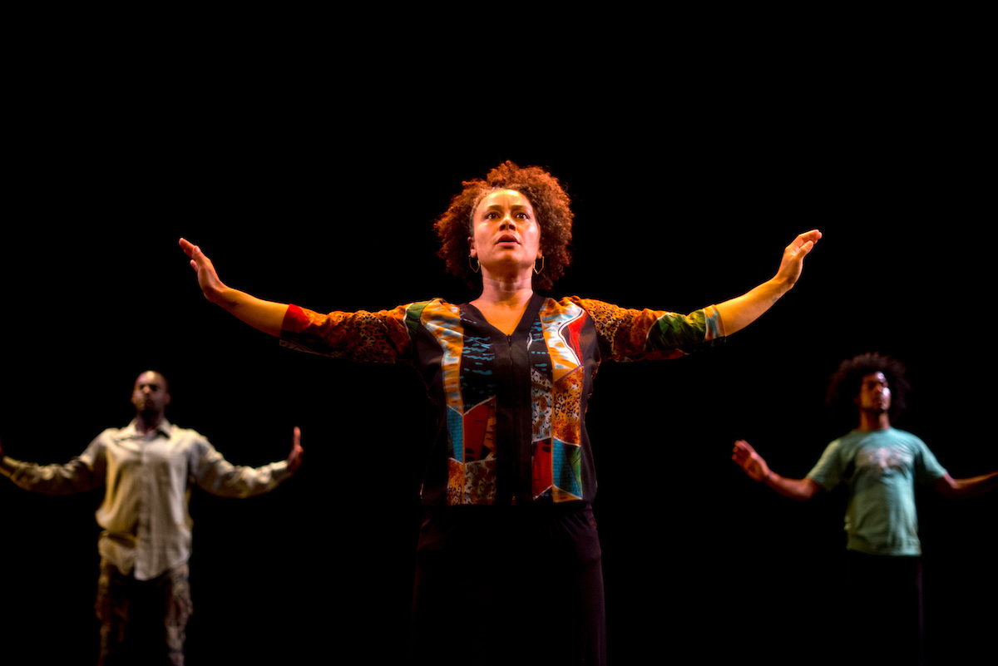
Pictured: (L-R): Shawn Hawkins, Cria merchant and Alexander Zander Brown; Photo Credit: Alan Kimara Dixon

FOR IMMEDIATE RELEASE

KENDRA KIMBROUGH DANCE ENSEMBLE ANNOUNCES
20TH ANNIVERSARY SEASON
FEATURING THE WORLD PREMIERE OF ANGST: 3 AM
BY ARTISTIC DIRECTOR KENDRA KIMBROUGH BARNES
The season will also feature Reflections, in tribute to Roquisha Townsend.

October 22 and 23, 2016 at Odell Johnson Theater at Laney College in Oakland
Tickets: $20-$40; kkde20.brownpapertickets.com

SAN FRANCISCO, September 16, 2016 — Kendra Kimbrough Dance Ensemble (KKDE) celebrates its 20th Anniversary Season, October 22 and 23 at the Odell Johnson Theater at Oakland’s Laney College. This exciting new season will feature the World Premiere of Angst: 3AM by Artistic Director Kendra Kimbrough Barnes, and Reflection, a reunion of past and present company dancers performing in tribute to founding member Roquisha Townsend.

Offering another perspective on the subject of African American identity, Angst: 3AM focuses on the ways in which stress – psychological, economic, physical and otherwise – impacts relationships within the black community, and in particular the development of adolescent boys.

“ANGST: 3 AM intimately looks at anxiety in and among African American boys, during their self-identity formation, and how it affects the relationships within their families and the community,” explains Barnes. She explain that the topic was inspired by her own teenaged son, who struggles with standing in his power, confident and unafraid, in a world that appears to be so afraid of him. Barnes adds, “This is a critical time in society and African-American culture to talk about the challenges of Black boys and how their internal and external experiences with anxiety play out in relationships with families, schools, and the larger communities.”

Barnes’s creative process for ANGST: 3 AM is entirely collaborative and incorporates interviews and research with families and experts into the final script which is overseen by Script Director Delina Patrice Brooks. The sound score includes Alexander Zander Brown's haunting original song Let the Wind Flow, juxtaposed to the soothing sounds of Healing Sound Sculptress Gina Breedlove.

Also on the program is Reflections, a reunion of KKDE current and former members performing a compilation of past repertory in tribute to founding member Roquisha Townsend, who lost her battle to kidney cancer in October 2015. Throughout the years, Townsend performed in some of KKDE's anchoring works such as Legacy: Soul Quest, Rosangela Silvestre's Oya, and KKDE’s last major production of In The Meantime. When she wasn't an active member of the company, Townsend was always an active supporter, a dear friend and beloved colleague for more than 20 years.

The dancers of the Kendra Kimrbough Dance Ensemble are Alexander Zander Brown, Shawn Hawkins, Noah James, Cria Merchant, Patricia Ong.

Returning company members performing in Reflections are Regina Califa Calloway Nzo Califa Dance Works, Anissa Carthen, Bianca Coleman, Clairemonica Figueroa, Marianna Hester, Jade Itiene, Kysha Mitchell, Lavinia Mitchell, Paula Plessas, Shelley Davis Roberts, Valrie Sanders, Frances Sedayao, Elize Selvarajah, Elizabeth Soberanes, Phylicia Stroud, Nafi Watson.

ABOUT KENDRA KIMBROUGH DANCE ENSEMBLE (KKDE)
Kendra Kimbrough Dance Ensemble (KKDE) was founded in 1996 by Kendra Kimbrough Barnes. The Ensemble’s mission is to bridge diverse cultures and communities through thought-provoking performances that address the common human experiences of its audience. KKDE represents a range of ages and body-types and incorporates a variety of dance styles to inform audiences about a variety of sociocultural issues. The Ensemble creates and presents dance works that build upon a wide array of dance genres, including a fusion of modern dance with movement from African, Brazilian, and North Indian cultures.

Since its founding, KKDE has self-produced numerous home seasons in Oakland, as well as producing concerts and collaborations in San Francisco. Artistic Director Barnes has worked in collaboration with dancers, musicians, and poets in order to realize her vision. KKDE has toured throughout Southern and Northern California and in Salvador, Bahia Brazil, and performed in several Bay Area dance festivals, including the East Bay Dance Series, Oakland Arts Festival, WestWave Dance Festival, Black Choreographers Festival, and ODC’s Pilot and House Special. Barnes is also an alum of the Artist in Residency program at Headlands Center for the Arts and at CounterPULSE/SF. With these critical resources and the mentorship of Rhodessa Jones of Cultural Odyssey, Barnes developed Home Is That Way? (2010), a dance-drama exploring the effects of the incarceration of a loved one on a family. In 2012 KKDE presented a successful production of In The Meantime, a dance-drama about breast cancer prevention and awareness in collaboration with Delina Patrice Brooks.

ABOUT KENDRA KIMBROUGH BARNES
Having performed with such notables as the late Malonga Casquelord’s Fua Dia Congo, Chitresh Das’ Chhandam School of Kathak Dance, Donald Byrd, Robert Moses, Robert Henry Johnson, Bebe Miller, Bill T. Jones, and Roseangela Silvestre, Kendra Kimbrough Barnes founded her own ensemble in 1996. She has been a guest choreographer for San Francisco State University's Dance Department, Dimensions Extensions Youth Performance Ensemble, Move Dance Theater of Oakland, and Abundant Life Christian Fellowship (staging a 100+ cast for a 4,000+ audience). KKDE has presented work at the East Bay Dance Festival, Alice Arts Center, the Black Choreographers Festival, Summerfest/WestWave Dance Festival, and Dance Mosaic. Barnes has taught dance to adults and children of all ages through Dimension’s Rites of Passage program in Oakland at the Malonga Casquelourd Center for the Arts and jazz, Pilates and yoga at San Mateo, Laney and SF City Colleges. She has been an artist in residence at the Headlands Center for the Arts and is a 2010 AIR at CounterPULSE.

Barnes is also co-founder/director for the Black Choreographers Festival (BCF). Since 2005 BCF has served local, national and international artists with over 150 public events, acknowledging the diverse artistic expression within the context of African and African American dance and culture. Under her direction, K*Star*Productions, the presenting organization for BCF and KKDE, has received funding from the City of Oakland Cultural Arts Program, CA$H, The Irvine Foundation, the Zellerbach Family Fund, Alameda County Arts Commission, East Bay Community Foundation, California Arts Council, and The Walter and Elise Haas Fund Foundation.

Barnes holds a BA in Dance from San Francisco State University and a MA in Arts Administration from Golden Gate University. She graduated with honors and is a recipient of the "Who's Who Among Students in American Universities and Colleges" Award and as of 2008 the "Who's Who Among American Women.”

The 20th Anniversary Season of the Kendra Kimbrough Dance Ensemble is made possible by the generous funding of The City of Oakland Cultural Funding Program, Zellerbach Family Foundation, Alameda County Arts Commission, and the California Arts Council. KKDE/K*STAR*PRODUCTIONS is fiscally sponsored by Dimensions Dance Theater.

Tickets for Kendra Kimbrough Dance Ensemble’s 20th Anniversary Season are $20 when purchased in advance and $30 at the door. Tickets for seniors, students and youth under 14 are $20. VIP Packages are available for $40 and include preferred seating and a commemorative memento.

To purchase tickets, go to kkde20.brownpapertickets.com

Hi-Res Photos are available for download at www.kkde.net/press

Company Website: www.kkde.net

